<page_start no = 1>
<sol_start id=1>
1. Convex lens is used to produce real image.
<sol_end>

<sol_start id=2>
2. Power (P) =
In case I :
‘f = 10 cm given
f = = 0.1 m
p = = 10D
In case II
f = 20 cm
f =
p =
<sol_end>
<page_end>

<page_start no = 2>
<sol_start id=3>
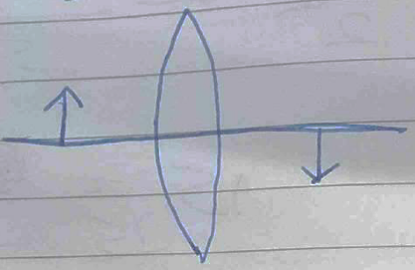
3. u = –5 cm
v = +10 cm
f =
∴ It is convex lens because f is +ve
<sol_end>

<sol_start id=4>
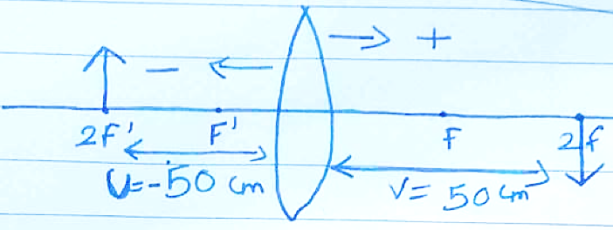
4. u = –50 cm
v = 50 cm
f = +25 cm
f =
f = 0.25 m
Power =
p =
p =
<sol_end>
<page_end>

